**WIDENER UNIVERSITY**

**DEPARTMENT OF ELECTRICAL ENGINEERING**

**Engr 112 – Computer Programming and Engineering Problem Solving**

**Milestone Project 3**

**OBJECTIVES**: You will use what you have learned from all previous labs

**INSTRUCTIONS**: Carefully follow the instructions on each page. You will submit numerous screenshots. Search INSERT or SCREENSHOT in uppercase to find out the exact pages. There may be questions to answer. Search QUESTION in uppercase to find the exact pages

**PREREQUISITES**:

* "How to use the Snipping Tool on Windows 10" video at <https://www.youtube.com/watch?v=ayi5-7QPNcA>
* "How to Take a Screenshot on a Mac" video at <https://www.youtube.com/watch?v=h3RkDPfphSQ>

**COMMENTS**: I do NOT want a screenshot of your entire desktop window. Generally, you only need to take a screenshot of the MSVS window or perhaps just a portion. WHILE examples, see the screenshots in this document.

Ensure that you complete the entire lab. You will know when you see "THIS IS THE LAST PAGE OF THE LAB".

**CAUTION**: Any time you see **JohnDoe** or **John Doe** in the instructions, replace with **YOUR NAME**. If you see JD, replace with **YOUR INITIALS**.

This exam consists of several exercises that will demonstrate how well you have learned the C++ programming concepts from previous labs What you can do with C++ functions

* Go to <https://www.tutorialspoint.com/compile_cpp_online.php>
* The **codingground** webpage appears. The **Edit** pane is on the left. The **Result** pane is on the right.
* In the **Result** pane on the right, click on the left most icon to change the **Edit** pane to be on top and the **Result** pane to be on the bottom



The above compiler can sometimes return errors like Unable to create src file because there are too many users. First, try to compile again. If you continue to have problems, you can use this alternative online compiler



Click on the third icon to change the orientation to vertical from horizontal

* Copy/Paste the following code into the editor pane. Copy all of it.

#include <iostream>

#include <sstream>

#include <fstream>

#include <cmath>

#include <cstdlib>

#include <string>

#include <cstring>

#include <ctime>

using namespace std;

int Deck[52],JD_Hand[10],Dealer_Hand[10];

int CardsDealt;

void name() {

time_t rawtime;

struct tm* timeinfo;

char buffer[80];

time(&rawtime);

timeinfo = localtime(&rawtime);

strftime(buffer, sizeof(buffer), "%m-%d-%Y %H:%M", timeinfo);

string str(buffer);

cout << "\n";

cout << "My name is John Doe\n";

cout << "The date is "<< str << "\n";

}

// Your lab exercise code begins here

int main() {

name();

// Your lab exercise code ends here

}

* Find the line

**cout << "My name is John Doe\n";**

* Change **John Doe** to your name
* Click on **Execute**. The program should compile successfully

The purpose of this project is to build a Black Jack program, step by step. In each exercise, you will create a needed function and demonstrate that it works correctly. In the last two exercises, you will play a hand using all of these functions and determine who wins.

NOTE: For each exercise, you will create a new function. Your screenshot for that exercise need only show the new function plus whatever is in the **main()** function

**Exercise 1**

Create function **printDeck()** to print out all 52 elements of array **Deck**, which represents the deck of cards. NOTE: **Deck** has already been defined as a global variable that all functions can access.

* Remove the code between the comment lines, including **int** **main()** and **name()**
* Copy/paste the following

**void printDeck() {**

**int i;**

**for (aaa) {**

**cout << bbb << " ";**

**}**

**cout << "\n";**

**for (ccc) {**

**cout << ddd << " ";**

**}**

**cout << "\n";**

**}**

**int main() {**

**name();**

**printDeck();**

REMEMBER: Replace **JD** with your initials

* Replace **aaa** through **ddd** so that it produces the output shown below; i.e. print out **2** lines of **26** values**. Deck[0] to Deck[25]** on one line and then **Deck[26] to Deck[51]** on a second line
* NOTE: Element values of **0** are expected
* Click on **Execute**. The program should compile successfully
* Take a screenshot that shows both the code you added between the **// Your lab exercise** … comment lines and the **Result** pane showing the output

The **Result** pane should look like

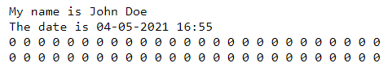

INSERT YOUR SCREENSHOT HERE. IT IS WORTH ***5 POINTS***

ONLY INCLUDE THE CODE OF THE NEW FUNCTION AND MAIN FUNCTION

********* ALERT **********

COPY/PASTE YOUR CODE HERE BEFORE GOING ON

ONLY COPY THE CODE OF THE NEW FUNCTION AND MAIN FUNCTION

**Exercise 2**

Integer array **Deck** represents the deck of cards.

Create function **initDeck()** to initialize **Deck** with numbers from **1** through **52**. Then call **printDeck()** to print out all **52** elements of array **Deck**.

* Keep the code for all previously created functions.
* Remove the code between the comment lines, including **int** **main()** and **name()**
* After last created function, copy/paste the following

**void initDeck() {**

**int i;**

**for (aaa) {**

**bbb**

**}**

**}**

**int main() {**

**name();**

**initDeck();**

**printDeck();**

REMEMBER: Replace **JD** with your initials

* Replace **aaa** through **bbb** so that it produces the output shown below; i.e. **Deck[0] = 1, Deck[1] = 2,** and so on until **Deck[51] = 52**
* NOTE: Calling **printDeck()** will print out the initialized values of array **Deck**
* Click on **Execute**. The program should compile successfully
* Take a screenshot that shows both the code you added between the **// Your lab exercise** … comment lines and the **Result** pane showing the output

The **Result** pane should look like

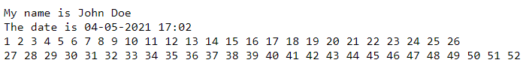

INSERT YOUR SCREENSHOT HERE. IT IS WORTH ***5 POINTS***

ONLY INCLUDE THE CODE OF THE NEW FUNCTION AND MAIN FUNCTION

********* ALERT **********

COPY/PASTE YOUR CODE HERE BEFORE GOING ON

ONLY COPY THE CODE OF THE NEW FUNCTION AND MAIN FUNCTION

**Exercise 3**

**JD_Hand** is a 10 element integer array that represents the cards in your hand. **Dealer_Hand** is a 10 element integer array that represents the cards in the dealer's hand.

Create function **printHands()** to print all elements of **JD_Hand** and **Dealer_Hand** on separate lines

* Keep the code for all previously created functions.
* Remove the code between the comment lines, including **int** **main()** and **name()**
* After last created function, copy/paste the following

**void printHands() {**

**int i;**

**cout << "JD_Hand is ";**

**for (aaa) {**

**cout << bbb[ccc] << " ";**

**}**

**cout << "\n";**

**cout << "Dealer_Hand is ";**

**for (ddd) {**

**cout << ddd[eee] << " ";**

**}**

**cout << "\n";**

**}**

**int main() {**

**name();**

**printHands();**

REMEMBER: Replace **JD** with your initials

* Replace **aaa** through **eee** so that it produces the output shown below; i.e. print out all **10** values of **JD_Hand** on one line and then all 10 values of **Dealer_Hand** on the second line
* NOTE: Element values of **0** are expected
* Click on **Execute**. The program should compile successfully
* Take a screenshot that shows both the code you added between the **// Your lab exercise** … comment lines and the **Result** pane showing the output

The **Result** pane should look like

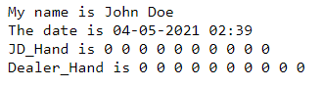

INSERT YOUR SCREENSHOT HERE. IT IS WORTH ***5 POINTS***

ONLY INCLUDE THE CODE OF THE NEW FUNCTION AND MAIN FUNCTION

********* ALERT **********

COPY/PASTE YOUR CODE HERE BEFORE GOING ON

ONLY COPY THE CODE OF THE NEW FUNCTION AND MAIN FUNCTION

**Exercise 4**

Create function **getValue(card)** to determine the **BlackJack** value of a card. The input argument is a number between **1** and **52**. The function returns an integer value from **2** through **10** and **11**.

In **BlackJack**, the values are as follows:

* An **Ace** is worth **11**
* A **Jack, Queen** and **King** are worth **10**
* All other cards are worth their face value, from **2** through **10**
* Suits do not matter

The following shows the incremental steps for mapping a card number to its **BlackJack** value. There are four groups of **13** numbers, from **1** through **52**

1. The top row is the card number
2. The second row shows the suit-independent number card rank using the modulus operator
3. The third row maps the number card rank to **Jacks, Queens, Kings** and **Aces**
4. The last row maps the card rank to its **BlackJack** value

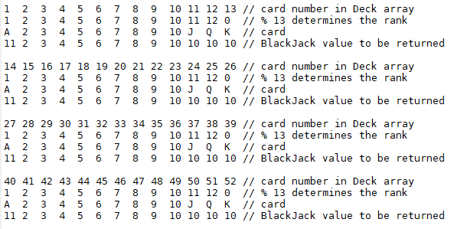

* Keep the code for all previously created functions.
* Remove the code between the comment lines, including **int** **main()** and **name()**
* After last created function, copy/paste the following

**int getValue(int card) {**

**int rank,value;**

**if (card == 0) {**

**return 0;**

**}**

**rank = card % aaa;**

**switch (bbb) {**

**case ccc:**

**case ddd:**

**case eee:**

**value = 10;**

**break;**

**case fff:**

**value = 11;**

**break;**

**default:**

**value = ggg;**

**}**

**return hhh;**

**}**

**int main() {**

**name();**

**int i, card, value;**

**srand(time(0));**

**for (i=1; i <= 5; i++) {**

**jjj = rand() % 52 + 1;**

**kkk = getValue(mmm);**

**cout << "Value for " << nnn << " is " << ooo << "\n";**

**}**

REMEMBER: Replace **JD** with your initials

* Replace **aaa** through **ooo** so that it produces the output shown below; i.e. you will generate **5** random numbers from **1** through **52** to test out the accuracy of **getValue()** and print out the results
* HINT: For **aaa**, choose the value that generates random numbers from **0** through **12**; i.e. the numbers in the second row of each grouping
* HINT: For **bbb**, choose the variable that has the range from 0 through 12
* HINT: For **ccc,ddd,eee** choose numbers from the second row of each grouping that have the value of **10** in the last row
* HINT: For **fff**, choose the number from the second row of each grouping that have the value of **11** in the last row
* Click on **Execute**. The program should compile successfully
* Take a screenshot that shows both the code you added between the **// Your lab exercise** … comment lines and the **Result** pane showing the output

Although the random numbers will be different, the **Result** pane should look like

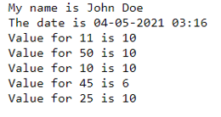

Run the program at least 5 times. Each time, verify that **getValue** returns the correct value by comparing to the table above. The first number is found in one of the four top rows. The second number should be the one found in the same column of the bottom row

For example, 11 is found in the top row of the first group. 10 is the value found in the last row of the same column. Similarly, 50 is found in the top row of the last group. 10 is found in the last row of the same column.

INSERT YOUR SCREENSHOT HERE. IT IS WORTH ***10 POINTS***

ONLY INCLUDE THE CODE OF THE NEW FUNCTION AND MAIN FUNCTION

********* ALERT **********

COPY/PASTE YOUR CODE HERE BEFORE GOING ON

ONLY COPY THE CODE OF THE NEW FUNCTION AND MAIN FUNCTION

**Exercise 5**

Create function **ShuffleDeck()** to shuffle the deck. Two random indices for **Deck** are generated; i.e. a number from **0** through **51**. The cards in the deck at those two index numbers are swapped. 100 swaps are performed to shuffle the deck. Then call **printDeck()** to print out all **52** elements of the newly shuffled deck.

* Keep the code for all previously created functions.
* Remove the code between the comment lines, including **int** **main()** and **name()**
* After last created function, copy/paste the following

**void ShuffleDeck() {**

**int i, JD_Temp, JD_Rand1, JD_Rand2;**

**for (i=1; i <= 100; i++) {**

**JD_Rand1 = rand() % 52;**

**JD_Rand2 = rand() % 52;**

**JD_Temp = aaa;**

**bbb;**

**ccc = JD_Temp;**

**}**

**for (i=0; i < 52; i++) {**

**if ((Deck[i] < 1) || (Deck[i] > 52)) {**

**cout << "ShuffleDeck is not correct\n";**

**}**

**}**

**}**

**int main() {**

**name();**

**initDeck();**

**srand(time(0));**

**ShuffleDeck();**

**printDeck();**

REMEMBER: Replace **JD** with your initials

* Replace **aaa** through **ccc** so that it produces the output shown below
* Click on **Execute**. The program should compile successfully
* Take a screenshot that shows both the code you added between the **// Your lab exercise** … comment lines and the **Result** pane showing the output

Although the random numbers will be different, the **Result** pane should look like

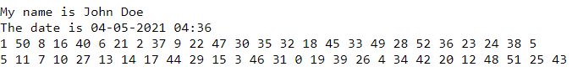

NOTE: If any number is not between **1** and **52**, then something is wrong. The second **FOR** statement checks for this.

INSERT YOUR SCREENSHOT HERE. IT IS WORTH ***10 POINTS***

ONLY INCLUDE THE CODE OF THE NEW FUNCTION AND MAIN FUNCTION

********* ALERT **********

COPY/PASTE YOUR CODE HERE BEFORE GOING ON

ONLY COPY THE CODE OF THE NEW FUNCTION AND MAIN FUNCTION

**Exercise 6**

Create function **evalMyHand()** to count the number of **BlackJack** points in **JD_Hand**. **evalMyHand**() will call **getValue()** to get the **BlackJack** value of each element in **JD_Hand**, which has **10** elements. Add them together to get the total **BlackJack** value of the hand. NOTE: If the value of the **JD_Hand** element is **0**, **getValue()** will return **0**

To test **evalMyHand()**, take the first 4 cards from **Deck;** i.e. copy the values of the first 4 elements of **Deck** into the first 4 elements of **JD_Hand**.

* Keep the code for all previously created functions.
* Remove the code between the comment lines, including **int** **main()** and **name()**
* After last created function, copy/paste the following

**int evalMyHand() {**

**int i,card,value,total=0;**

**for (aaa) {**

**card = JD_Hand[bbb];**

**value = getValue(ccc);**

**total = ddd;**

**}**

**return eee;**

**}**

**int main() {**

**name();**

**int i,myvalue;**

**initDeck();**

**srand(time(0));**

**ShuffleDeck();**

**for (i=0; fff; i++) {**

**JD_Hand[ggg] = Deck[CardsDealt++];**

**}**

**myvalue = hhh();**

**cout << "My hand value is " << jjj << "\n";**

**printDeck();**

**printHands();**

REMEMBER: Replace **JD** with your initials

* Replace **aaa** through **jjj** so that it produces the output shown below
* NOTE: Element values of **0** for **Dealer_Hand** are expected
* Click on **Execute**. The program should compile successfully
* Take a screenshot that shows both the code you added between the **// Your lab exercise** … comment lines and the **Result** pane showing the output

Although the random numbers will be different, the **Result** pane should look like

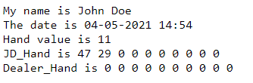

NOTE: Global variable **CardsDealt** is used to keep track of how many cards have been dealt. **CardsDealt++** advances to point to the next card.

INSERT YOUR SCREENSHOT HERE. IT IS WORTH ***10 POINTS***

ONLY INCLUDE THE CODE OF THE NEW FUNCTION AND MAIN FUNCTION

********* ALERT **********

COPY/PASTE YOUR CODE HERE BEFORE GOING ON

ONLY COPY THE CODE OF THE NEW FUNCTION AND MAIN FUNCTION

**Exercise 7**

Create function **evalDealerHand()** to count the number of **BlackJack** points in **Dealer_Hand**. **evalDealerHand()** will call **getValue()** to get the **BlackJack** value of each element in **Dealer_Hand**, which has **10** elements. Add them together to get the total **BlackJack** value of the hand. NOTE: If the value of the **Dealer_Hand** element is **0**, **getValue()** will return **0**

To test **evalDealerHand ()**, take the first 4 cards from **Deck;** i.e. copy the values of the first 4 elements of **Deck** into the first 4 elements of **Dealer_Hand**.

* Keep the code for all previously created functions.
* Remove the code between the comment lines, including **int** **main()** and **name()**
* After last created function, copy/paste the following

**int evalDealerHand() {**

**int i,card,value,total=0;**

**for (aaa) {**

**card = Dealer_Hand[bbb];**

**value = getValue(ccc);**

**total = ddd;**

**}**

**return eee;**

**}**

**int main() {**

**name();**

**int i,dlrvalue;**

**initDeck();**

**srand(time(0));**

**ShuffleDeck();**

**printDeck();**

**for (i=0; fff; i++) {**

**Dealer_Hand[ggg] = Deck[CardsDealt++];**

**}**

**dlrvalue = hhh();**

**cout << "Dealer's hand value is " << jjj << "\n";**

**printHands();**

REMEMBER: Replace **JD** with your initials

* Replace **aaa** through **jjj** so that it produces the output shown below
* NOTE: Element values of **0** for **JD_Hand** are expected
* Click on **Execute**. The program should compile successfully
* Take a screenshot that shows both the code you added between the **// Your lab exercise** … comment lines and the **Result** pane showing the output

Although the random numbers will be different, the **Result** pane should look like

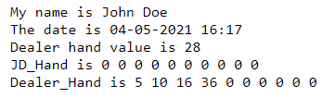

NOTE: Global variable **CardsDealt** is used to keep track of how many cards have been dealt. **CardsDealt++** advances to point to the next card.

INSERT YOUR SCREENSHOT HERE. IT IS WORTH ***10 POINTS***

ONLY INCLUDE THE CODE OF THE NEW FUNCTION AND MAIN FUNCTION

********* ALERT **********

COPY/PASTE YOUR CODE HERE BEFORE GOING ON

ONLY COPY THE CODE OF THE NEW FUNCTION AND MAIN FUNCTION

**Exercise 8**

In this exercise, you will write the code to deal out the first two cards from the deck to yourself and copy them as the first two elements in array **JD_Hand**. Then you will deal the next two cards from the deck to the dealer and copy them as the first two elements in array **Dealer_Hand**.

Global variable **CardsDealt** keeps track of the next card to be dealt from array **Deck**. That is, the **Deck[CardsDealt]** is the next card to be dealt. NOTE: Each time a card is dealt to either hand, **CardsDealt** must be incremented.

* Keep the code for all previously created functions.
* Remove the code between the comment lines, including **int** **main()** and **name()**
* After last created function, copy/paste the following

**int main() {**

**name();**

**initDeck();**

**srand(time(0));**

**ShuffleDeck();**

**printDeck();**

**// Deal out first two cards of the deck to JD_Hand**

**// Deal out the next two cards of the deck to Dealer_Hand**

**printHands();**

REMEMBER: Replace **JD** with your initials

* Replace the comment lines with the appropriate code
* HINT: Look at what you did in **Exercise 5** and **6** to deal out **4** cards to **JD_Hand** and **Dealer_Hand**. This time, deal out only **2** cards to each. Remember to use **CardsDealt** correctly
* Click on **Execute**. The program should compile successfully
* Take a screenshot that shows both the code you added between the **// Your lab exercise** … comment lines and the **Result** pane showing the output

Although the random numbers will be different, the **Result** pane should look like 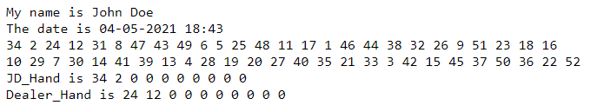

INSERT YOUR SCREENSHOT HERE. IT IS WORTH ***10 POINTS***

ONLY INCLUDE THE CODE OF MAIN FUNCTION

********* ALERT **********

COPY/PASTE YOUR CODE HERE BEFORE GOING ON

ONLY COPY THE CODE OF THE NEW FUNCTION AND MAIN FUNCTION

**Exercise 9**

Create function **PlayMyHand**() to play the cards in **JD_Hand**. According to **BlackJack** rules,

* After dealing out **2** cards, evaluate your hand; i.e. **JD_Hand**
* If the **BlackJack** value exceeds **16**, then no more cards need be drawn
* Otherwise, keep drawing another card until the **BlackJack** value does exceed **16**

So let's implement this logic

* Keep the code for all previously created functions.
* Remove the code between the comment lines, including **int** **main()** and **name()**
* After last created function, copy/paste the following

**int playMyHand() {**

**int count,num=2;**

**count = evalMyHand();**

**while (aaa < bbb) {**

**ccc[num++] = ddd[CardsDealt++];**

**eee = evalMyHand();**

**}**

**return fff;**

**}**

**int main() {**

**name();**

**int myvalue;**

**initDeck();**

**srand(time(0));**

**ShuffleDeck();**

**printDeck();**

**// As in Exericse 7, deal out 2 cards to JD_Hand**

**ggg = playMyHand();**

**cout << "My hand value is " << hhh << "\n";**

**printHands();**

REMEMBER: Replace **JD** with your initials

* Replace **aaa** through **hhh** so that it produces the output shown below
* Click on **Execute**. The program should compile successfully
* WARNING: Re-run the program until at least **4** cards have been dealt
* Take a screenshot that shows both the code you added between the **// Your lab exercise** … comment lines and the **Result** pane showing the output

Although the random numbers will be different, the **Result** pane should look like

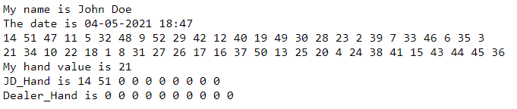

INSERT YOUR SCREENSHOT HERE. IT IS WORTH ***10 POINTS***

ONLY INCLUDE THE CODE OF THE NEW FUNCTION AND MAIN FUNCTION

********* ALERT **********

COPY/PASTE YOUR CODE HERE BEFORE GOING ON

ONLY COPY THE CODE OF THE NEW FUNCTION AND MAIN FUNCTION

**Exercise 10**

Repeat the logic of Exercise for the dealer's hand. So create function **PlayDealerHand**() to play the cards in **Dealer_Hand**.

* Keep the code for all previously created functions.
* Remove the code between the comment lines, including **int** **main()** and **name()**
* After last created function, copy/paste the following

**int PlayDealerHand () {**

**int count,num=2;**

**count = evalMyHand();**

**while (aaa < bbb) {**

**ccc[num++] = ddd[CardsDealt++];**

**eee = evalMyHand();**

**}**

**return fff;**

**}**

**int main() {**

**name();**

**int dealervalue;**

**initDeck();**

**srand(time(0));**

**ShuffleDeck();**

**printDeck();**

**// As in Exericse 7, deal out 2 cards to Dealer_Hand**

**ggg = PlayDealerHand ();**

**cout << "Dealer's hand value is " << hhh << "\n";**

**printHands();**

REMEMBER: Replace **JD** with your initials

* Replace **aaa** through **hhh** so that it produces the output shown below
* Click on **Execute**. The program should compile successfully
* WARNING: Re-run the program until at least **4** cards have been dealt
* Take a screenshot that shows both the code you added between the **// Your lab exercise** … comment lines and the **Result** pane showing the output

Although the random numbers will be different, the **Result** pane should look like

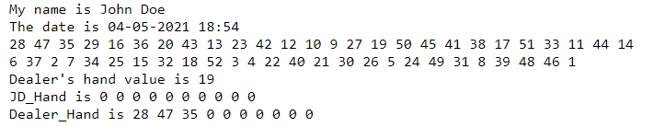

INSERT YOUR SCREENSHOT HERE. IT IS WORTH ***10 POINTS***

ONLY INCLUDE THE CODE OF THE NEW FUNCTION AND MAIN FUNCTION

********* ALERT **********

COPY/PASTE YOUR CODE HERE BEFORE GOING ON

ONLY COPY THE CODE OF THE NEW FUNCTION AND MAIN FUNCTION

**Exercise 11**

Now let's play a hand of **BlackJack** and see who wins. The program logic is as follows

* Initialize the deck
* Call **srand(time(0))** to seed the random number generator
* Shuffle the deck
* Print the card order in the shuffled deck
* Deal out two cards to **JD_Hand** and then two cards to **DealerHand** as was done in **Exercise 7**
* Play your hand as was done in **Exercise 8**.
* Play the dealer's hand as was done in **Exercise 8**.
* Print out the score of **JD_Hand** and **DealerHand**
* Print out the cards in **JD_Hand** and **DealerHand**
* Use an **IF-ELSE-IF** statement to determine the results. Check for the following in the indicated order
  + If your score exceeds **21** then print **"I lost".**
  + If your score does not exceed **21** and the dealer score exceeds **21** then print **"I won**"
  + If neither score exceeds **21** then compare scores
  + If the score is tied, then print **"We push"**
  + If your score is higher than the dealer score then print **"I won"**
  + If dealer score is higher than yours, print **"I lost"**
* Keep all of the code for the functions you created
* Remove the remaining code, including **int** **main()** and **name()**
* Copy/paste the following

int main() {

name();

int myvalue,dealervalue;

// Initialize the deck

srand(time(0));

// shuffle the deck

// print the order of cards in the shuffled deck

// deal the first two cards of your hand

// deal the first two cards of the dealer hand

// play your hand and save your score

// play the dealer hand and save the score

cout << "My hand value is " << aaa << "\n";

cout << "Dealer's hand value is " << bbb << "\n";

// print out the cards in both hands

if (ccc) {

cout << "I lost\n";

} else if (ddd) {

cout << "I won\n";

} else if (ddd) {

cout << "We push\n";

} else if (fff) {

cout << "I won\n";

} else {

cout << "I lost\n";

}

* Replace all comment lines as needed AND
* Replace **aaa** through **fff** so that it produces the output shown below

REMEMBER: Replace **JD** with your initials

* Click on **Execute**. The program should compile successfully
* Take a screenshot that shows both the code in the **main()** function and the **Result** pane showing the output. NOTE: You may need to adjust the window size of the **Edit** and **Result** panes and scroll up or down in each window to fit everything

Although the random numbers will be different, the **Result** pane should look like

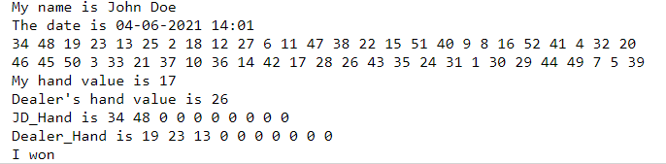

INSERT YOUR SCREENSHOT HERE. IT IS WORTH ***10 POINTS***

ONLY INCLUDE THE CODE IN THE **MAIN** FUNCTION

********* ALERT **********

COPY/PASTE YOUR CODE HERE BEFORE GOING ON

ONLY COPY THE CODE OF THE MAIN FUNCTION

**Exercise 12**

Now re-run the program to generate a different result

* Click on **Execute**. The program should compile successfully
* Take a screenshot that shows both the code in the **main()** function and the **Result** pane showing the output. NOTE: You may need to adjust the window size of the **Edit** and **Result** panes and scroll up or down in each window to fit everything

INSERT YOUR SCREENSHOT HERE. IT IS WORTH ***5 POINTS***

ONLY INCLUDE THE CODE IN THE **MAIN** FUNCTION

********* ALERT **********

COPY/PASTE YOUR CODE HERE BEFORE GOING ON

THIS TIME, COPY ALL OF THE CODE SO THAT THE PROGRAM CAN BE RUN